Invoice a Repair Order using ROM: This topic covers closing, invoicing, settling a repair order through ROM.

Access an Existing Repair Order: If the screen is blank to start with, either type the RO number in the Repair Order field or use the Search to look it up. If you already have an RO open, you will need to click New Repair Order to clear the screen and open the RO you want to add the charges to.

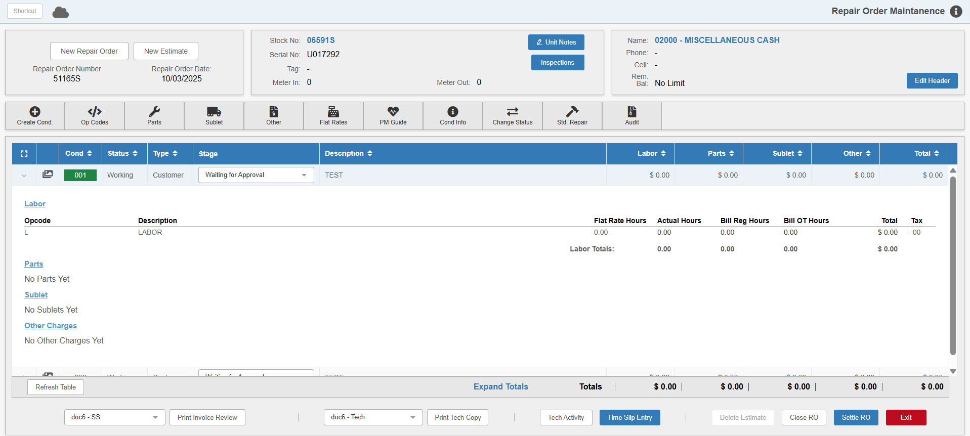

Review Labor: Expand the condition details (as shown in the image above). Click on the hour value under Bill Reg Hours. A window of all time slips on this RO/Condition/Opcode appears.

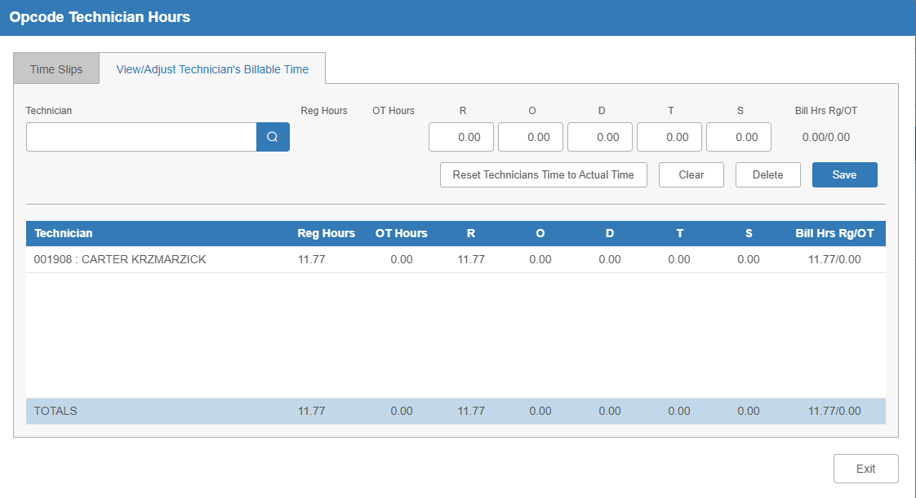

Time Slip Tab: View all times slips by tech.

View/Adjust Technicians Billable Time Tab: Click on a Tech to change billed hours as needed (Reg, O/T, Double, Triple, etc.). Once finished, click Save

Click Exit to return to the main screen.

Invoice Review: Preview the invoice prior to printing (see below for an invoice sample).

- Select the PDF printer to display your invoice with totals to the screen.
- Select a printer to get a printout.

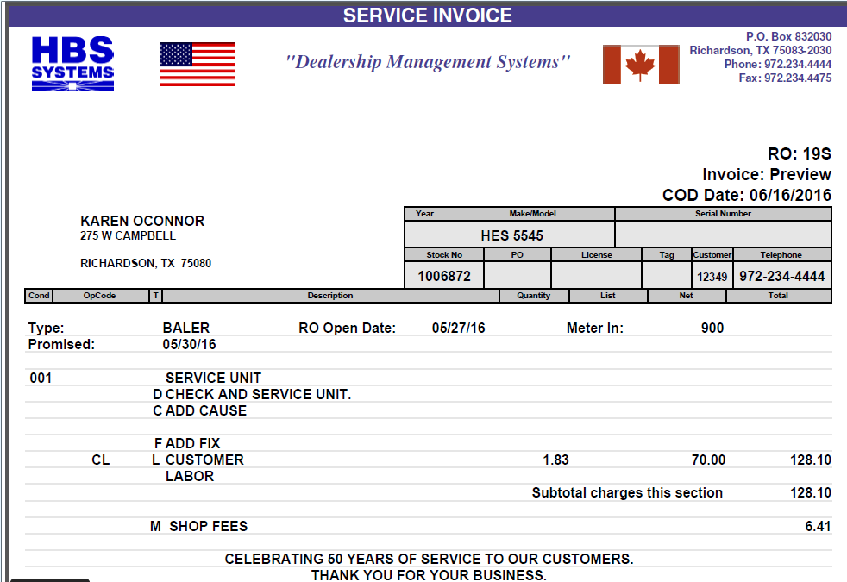

Settle the RO: Click on the Settle RO button at the bottom of the main screen to settle the RO invoice. The following screen will appear:

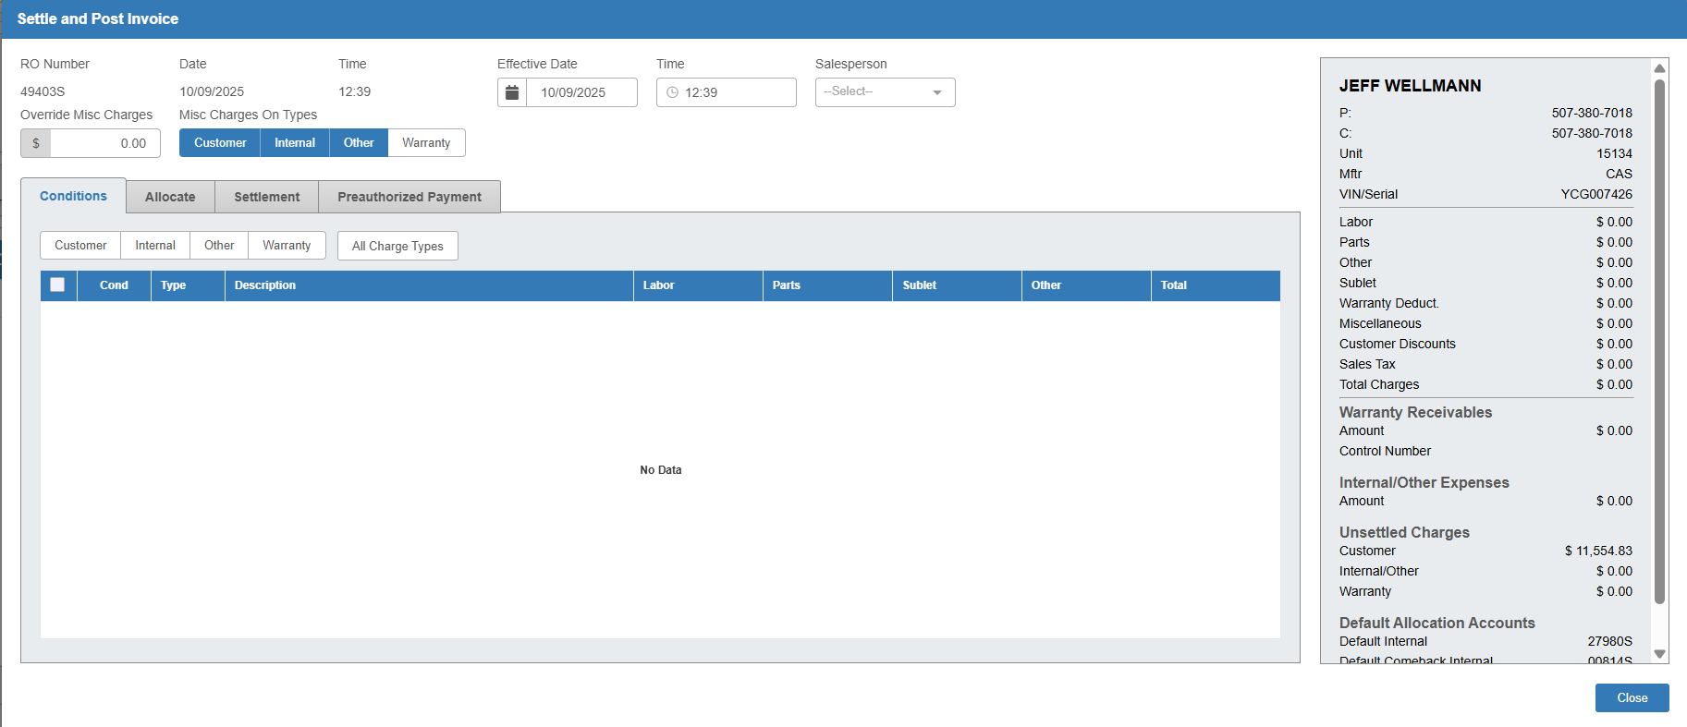

Salesperson: Make sure you have the salesperson ID selected in the screen header, or you will not be able to craete the invoice.

Conditions Tab: In this tab, click on the All Charge Types button in the center of the screen to have all the conditions available for invoicing show up:

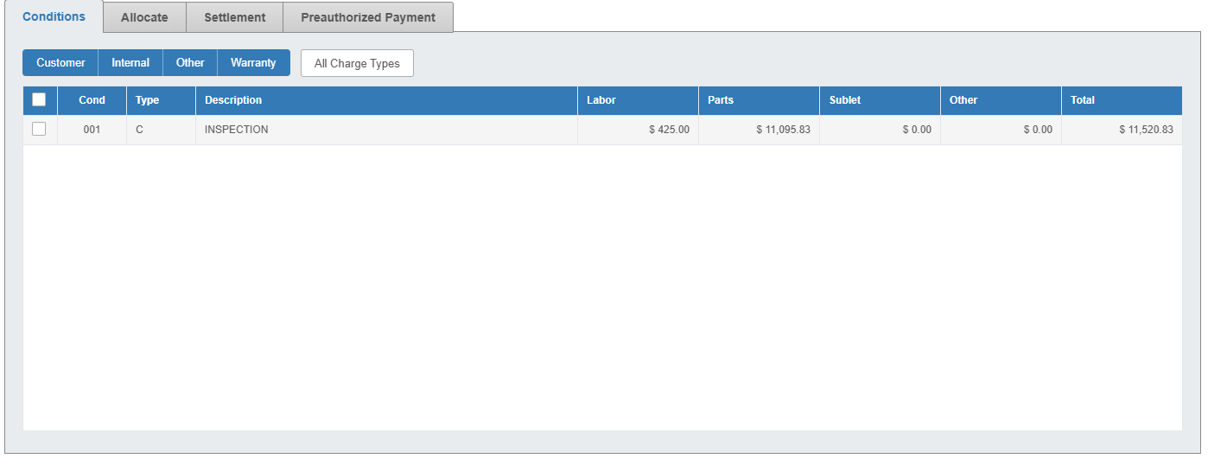

Check the box next to each condition you want to invoice. If you would like to invoice all of them at once, you can check the box in the far-left column of the grid to select all the conditions.

Settlement Tab: Select the Settlement tab to proceed with payment.

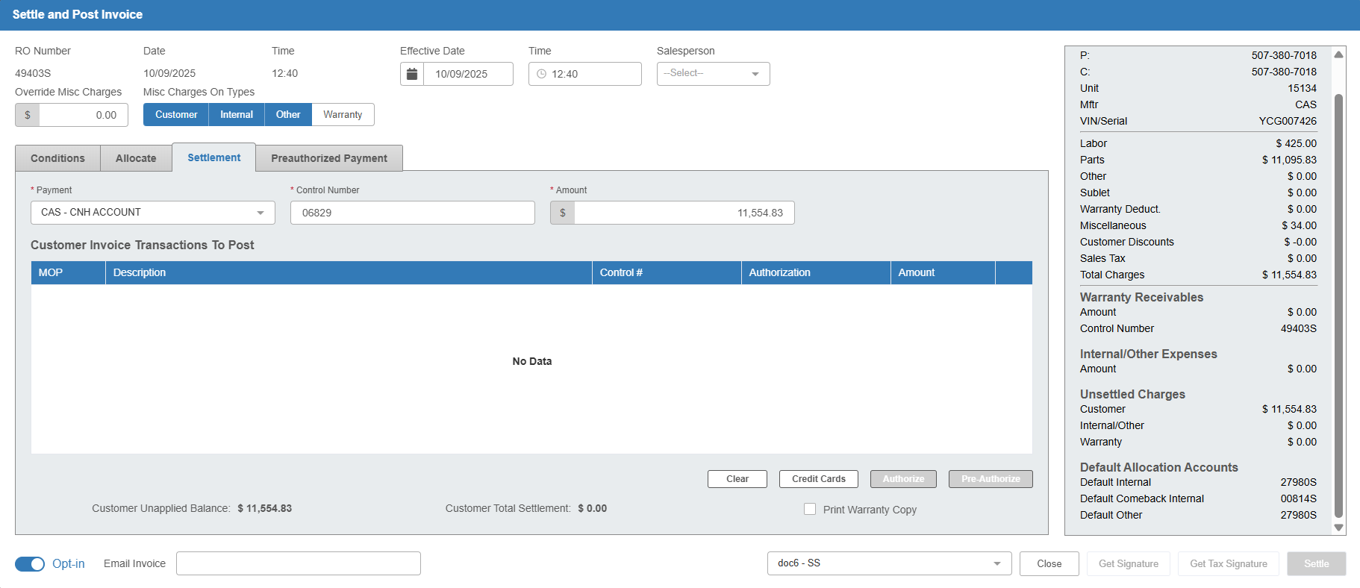

Payment: Select the method of payment. The field will default to the method selected in the RO header, but can be changed as needed.

Control Number: Enter a control number if needed. If this is a Customer RO, this field will default to the customer number.

Amount: Make sure the amount is correct, then tab through the field to have it added to the grid as a pending payment.

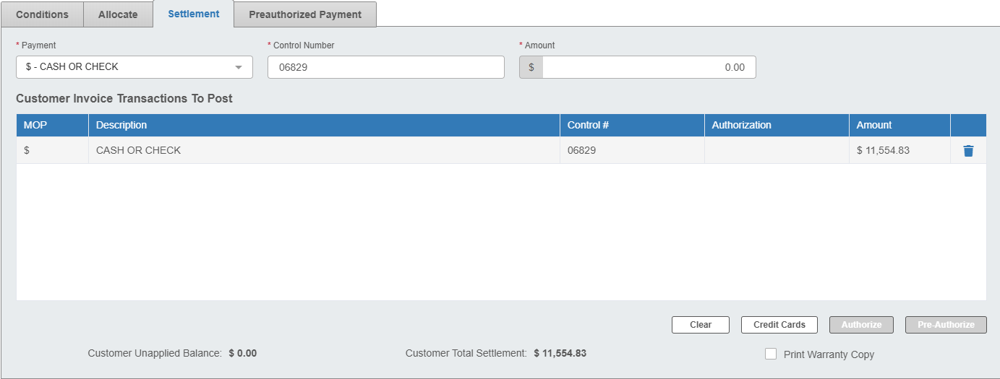

Printer: Set the printer to receive the invoice.

Settle: Click this button to create the invoice. The invoice will generate to the chosen printer. If this invoice completely pays the condition line’s charges, then the condition will be marked as Closed on the RO. If this is the only condition on the invoice, the RO itself will be closed and only available from that point on in Repair Order History (ROH).

